MOVIE MASTER
AI-Powered Film Intelligence Platform
Project Plan · Spring 2025

1. Overview
Movie Master is an AI-powered application that enables users to explore, understand, and interact with movies through natural language. By combining structured data (movie database and user ratings) with unstructured data (transcripts and summaries), the platform uses AI to transform raw content into rich, interactive experiences.

Core user capabilities include:
• Search for any movie by title
• View AI-generated summaries derived from transcripts
• Chat with an AI movie expert powered by contextual knowledge
• Translate summaries into other languages
• Rate movies and receive personalized AI-enhanced recommendations

Application Goals & Values
Movie Master is built around three foundational values that guide design and development decisions:
• Multilingual translation support ensures the platform is usable by a global audience, regardless of language. The UI is designed to be intuitive and responsive across devices. Accessibility
• All AI-generated content (summaries, recommendations, chat responses) is clearly identified as AI-generated. The system explains its recommendations in plain language so users understand why content is surfaced. Transparency
• User ratings and preferences are stored securely and used only to improve that user's own experience. No personal data is shared with third-party services beyond what is required for AI inference. Privacy

2. Core Features

A. Movie Retrieval & Processing
• Search movies by title using TMDB and OMDb APIs
• Retrieve metadata — title, year, genre, cast, crew, posters, trailers, ratings
• Fetch and store transcripts for AI processing
• Cache processed outputs (summaries, embeddings) to avoid redundant computation

B. AI Movie Summarization
Input sources (in priority order):
◦ Primary: Full movie transcript
◦ Fallback: Aggregated online summaries
Configurable output options:
◦ Short summary: 1–5 paragraphs (user-selectable length)
◦ Optional detailed scene-by-scene breakdown
◦ Optional top 3–5 character profiles

C. AI Chat — Movie Expert Agent
• Dedicated chat interface per movie
• Model context includes the movie summary, extracted facts, and character profiles
• Capabilities: plot and character Q&A, theme explanation, scene discussion
• Built on the assistant-ui React library for a polished, production-ready chat UI

D. Translation
• Translate AI-generated summaries into other languages via Azure AI Translator
• Optional: translate user chat inputs and responses in real time

E. Ratings & Recommendations
• Users rate movies on a 1–5 star scale (Letterboxd-inspired UI)
• System stores ratings and generates recommendations based on genre similarity
• Optional AI-enhanced recommendations with natural language explanations

F. Recommendation Engine (Planned Enhancement)
• Embedding similarity — semantic matching via Azure AI Search vector search
• Collaborative filtering — user behavior-based recommendations
• AI-generated explanations: "You may like this because..."

3. Non-Functional Requirements
The following non-functional requirements define the quality standards and operational constraints the system must meet:

Category | Requirement
Scalability | Backend designed stateless (FastAPI) to support horizontal scaling. Summary caching prevents redundant AI calls as the movie library grows.
Reliability | Graceful degradation if AI services are unavailable — the app falls back to cached summaries or displays a user-friendly error. TMDB/OMDb failures fall back to the secondary source.
Security | User data (ratings, preferences) stored with access controls. API keys for Azure and movie data services managed via environment variables, never exposed in client code.
Usability | UI must be navigable without a tutorial. Chat interface follows familiar messaging conventions. Mobile-responsive layout required.
Rate Limit Handling | TMDB and OMDb API calls managed with retry logic and request throttling. Summary caching reduces Azure OpenAI token usage and cost.
Maintainability | All AI-generated code reviewed against a defined style guide. GitHub Actions CI runs automated tests on every push to main, ensuring no regressions.

4. System Architecture
The diagram below illustrates how the major system components interact — from the user-facing frontend through the backend API layer, database, AI services, and external data sources.

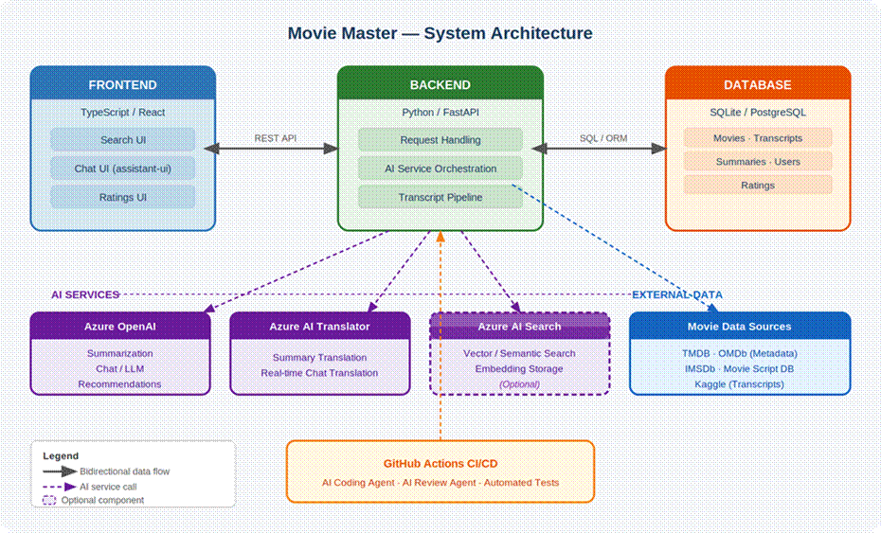

Component summary:
• Frontend (TypeScript/React + assistant-ui) — user interface for search, chat, and ratings
• Backend (Python/FastAPI) — orchestrates requests, AI service calls, and the transcript pipeline
• Database (SQLite/PostgreSQL) — stores movies, transcripts, cached summaries, users, and ratings
• Azure AI Services — OpenAI for chat and summarization, Translator for multilingual support, AI Search (optional) for vector recommendations
• External Data Sources — TMDB and OMDb for metadata; IMSDb, Movie Script Database, and Kaggle for transcripts
• GitHub Actions CI/CD — AI coding and review agents plus automated test runs on every push

5. Movie Information APIs
Two complementary APIs provide comprehensive movie metadata and ratings data:

TMDB — The Movie Database (Recommended Primary Source)
TMDB offers one of the most complete free API ecosystems for non-commercial use. It excels at images (posters, backdrops, cast profiles), credits, and discovery features (trending, now playing, upcoming). Documentation and SDKs are mature, and rate limits are generous enough for iterative development without constant throttling.
What you get: Title, year, genre, cast, crew, posters, trailers, ratings, and recommendations
Why it fits: Primary metadata source; genre and similarity data feed directly into the recommendation engine
Docs: https://developer.themoviedb.org

OMDb — Open Movie Database (Secondary / Fallback Source)
A long-standing RESTful API returning compact JSON with title, series, and episode data. Supports search by title or IMDb ID. Particularly strong for aggregated third-party ratings (IMDb, Rotten Tomatoes, Metascore) that TMDB does not natively provide.
Why it fits: Lightweight fallback and supplementary ratings source
Docs: https://www.omdbapi.com

6. Movie Script & Transcript Sources
The following sources provide movie scripts and transcripts that feed the AI summarization pipeline. They range from live scraping targets to pre-built pipelines and ready-to-use datasets.

IMSDb — Internet Movie Script Database
The largest freely accessible collection of movie screenplays online, covering hundreds of films in plain text format.
Why it fits: Scripts can be scraped or manually retrieved for the transcript pipeline. Works well combined with TMDB for metadata enrichment.
Implementation note: Plain HTML pages — use BeautifulSoup in Python (integrates cleanly with FastAPI).
Site: https://imsdb.com

Movie Script Database (GitHub) (Best for Bulk Scripts)
A GitHub project that aggregates movie scripts from multiple sources — including IMSDb, Screenplays, DailyScript, ScriptSavant, AwesomeFilm, ScriptSlug, and more. Uses parallel processing to accelerate downloads and integrates directly with the TMDB API for metadata enrichment.
Why it fits: This is essentially a pre-built pipeline that does exactly what the project needs — fetches scripts and links them to TMDB metadata. Blake (AI Engineer) can plug this directly into the summarization pipeline.
GitHub: https://github.com/Aveek-Saha/Movie-Script-Database

Kaggle — Movie Scripts Corpus
Pre-downloaded, cleaned datasets of movie scripts available for immediate use — no scraping required.
Why it fits: Fastest path to a working dataset for development and testing before a live scraping pipeline is in place.
Dataset (Corpus): https://www.kaggle.com/datasets/gufukuro/movie-scripts-corpus
Dataset (Scripts): https://www.kaggle.com/datasets/parthplc/movie-scripts

7. AI Services (Azure)
The platform requires a minimum of two AI services. The following are planned:

Service | Role | Capabilities
LLM / Chatbot  Azure OpenAI | User-facing AI interactions; bridges backend data with frontend UI | Conversation, question answering, context management
Summarization Model  Azure OpenAI | Processes transcripts into structured outputs | Movie summaries, key fact extraction, character breakdowns
Translation Model  Azure AI Translator | Translates AI-generated content for global accessibility | Summary translation, optional real-time chat translation
Vector Search  Azure AI Search (Optional) | Semantic recommendation engine | Embedding storage, similarity search for recommendations

8. AI Agent Strategy
The team will leverage AI agents both within the development workflow and within the GitHub repository to accelerate iteration while maintaining code quality and architectural consistency.

GitHub Coding Agent
• A dedicated AI agent will be configured within the GitHub repository with a defined set of development criteria
• The agent will generate feature drafts, starter code, and pull request contributions based on assigned GitHub Issues
• Generated code will follow consistent style guidelines enforced by the agent's configuration
• Team members review, refine, and validate all generated code before merging

GitHub Code Review Agent
• A separate agent will be configured specifically for code review, operating against a defined checklist of quality criteria
• GitHub Issues assigned to agents will be systematically reviewed and injected into pull requests
• This creates a structured, automated feedback loop before human review

CI/CD with GitHub Actions
• Automated test suites will be developed and executed via GitHub Actions
• Tests run automatically on every push to main, catching regressions early
• By offloading routine development and review work to AI, each team member is freed to take a more dynamic role — checking each other's work, enforcing accountability, and focusing on architecture and quality

Primary Agent Capabilities
• UI development — component scaffolding, assistant-ui integration
• Feature drafting — generating starter implementations from issue descriptions
• Prompt design — assisting with AI service prompt engineering and tuning
• API integration — generating patterns for Azure OpenAI and Translator integrations
• Debugging — suggesting fixes and improvements when issues arise

9. Team Roles
All team members are expected to contribute to software development and code review. Roles below reflect primary responsibilities; participation is cross-functional.

Role | Member(s) | Responsibilities
SW Developer / Engineer  AI Agent | AI Agent (GitHub Copilot / Azure AI) | Code generation, feature drafting, pull request contributions, prompt design assistance, API integration patterns, debugging suggestions
SW Developer / Engineer | Howard Kong | API development, AI service integration, DB design, UI/UX, chat interface, state management
Project Planner | Chase Balmer | GitHub board management, project proposal, plan updates, group coordination
AI Engineer | Blake Rossi | Prompt design, model deployment, summarization pipeline, chat tuning
Code Reviewer | Oscar Chen | Code quality verification, correctness validation, optimization, testing

10. Tech Stack
Layer | Technology
Frontend | TypeScript / React with assistant-ui library for AI chat components
Backend | Python — FastAPI for API development and AI service orchestration
Database | SQLite (development) / PostgreSQL (production) — movies, transcripts, ratings
Movie Data APIs | TMDB (primary metadata), OMDb (supplementary ratings)
Transcript Sources | IMSDb (scraping), Movie Script Database (bulk/GitHub), Kaggle datasets (dev/testing)
AI — Chat & Summarization | Azure OpenAI
AI — Translation | Azure AI Translator
AI — Search (Optional) | Azure AI Search — semantic search and embedding-based recommendations
Storage (Optional) | Azure Blob Storage — transcript file storage
CI/CD | GitHub Actions — automated testing on push to main

